**A**

**PROJECT REPORT ON**

## FUNCTION GENERATOR

### Abstract

Function generator has been widely used in each electronics field’s recent years. We will introduce some basic structure and working principles of a function generator, moreover a function generator which can create three kinds of wave: sine wave, square wave and triangle wave has been implemented. There are many ways to build the function generator; a method of combine the operational amplifier and discrete components is introduced in this project. First, we have used R2R Ladder to convert digital to analog signal. We have also used Top Win Software to burn the program into Atmega.The problem of obtaining a portable, cost effective student friendly device for working as a function generator thus for testing the circuits for any competition as in the technical fests. This report describes our device - which is an easy way to achieve this by the combination of microcontroller and a waveform generator IC.

# Contents

### List of Figures i

List of Tables ii

1. INTRODUCTION 1
2. CIRCUIT DESCRIPTION 3
   1. Block Diagram 3
   2. Working Principle 4
3. Implementation 9
   1. Hardware 9
   2. Software: 15
   3. Arduino Software: 17
4. PCB MAKING 18
   1. Steps for PCB Making Process: 18
5. RESULT: 20
   1. Advantages: 20
6. CONCLUSION AND FUTURE SCOPE 21
   1. Conclusion 21
   2. Future scope 21

REFERENCES 22

**List of Figures**

1.1 function generator 2

* 1. Block diagram 3
  2. For the Thevenin voltage calculate the no load output voltage. 6
  3. Contribution if bit 3 is active (the MSB): 6
  4. Contribution if 2 bits is active (the MSB): 7
  5. Contribution if 1 bit is active (the MSB): 7
  6. Circuit Diagram 8
  7. Atmega 328P 9
  8. PIN DIAGRAM 10
  9. Resistor 12
  10. Crystal Oscillator 12
  11. Capacitor 13
  12. LED 13
  13. Push Button 14
  14. Potentiometer 14
  15. LCD 15

4.1 PCB 19

i

# List of Tables

ii

# Chapter 1 INTRODUCTION

So many of the experiments in the advanced labs make use of oscilloscopes and function generators that it is useful to learn their general operation. Function generators are signal sources which provide a specifiable voltage applied over a specifiable time, such as a sine wave or triangle wave signal. These signals are used to control other apparatus to, for example, vary a magnetic field (superconductiv- ity and NMR experiments) send a radioactive source back and forth (Mossbauer effect experiment), or act as a timing signal, i.e., clock (phase-sensitive detection experiment). Oscilloscopes are a type of signal analyzer they show the experimenter a picture of the signal, usually in the form of a voltage versus time graph. Both function generators and oscilloscopes are highly sophisticated and technologically mature devices. The oldest forms of them date back to the beginnings of electronic engineering, and their modern descendants are often digitally based, multifunction devices costing thousands of dollars. This collection of exercises is intended to get you started on some of the basics of operating scopes and generators, but it takes a good deal of experience to learn how to operate them well and take full advantage of their capabilities. Function generator basics Function generators, whether the old analog type or the newer digital type, have a few common features:

A way to select a waveform type: sine, square, and triangle are most common, but some will give ramps, pulses, noise, or allows us to program a particular arbitrary shape

Typical frequency ranges are from 0.01 Hz to 10 MHz A way to select the waveform amplitude.

At least two outputs. The main output, which is where you find the desired wave- form, typically has a maximum voltage of 20 volts peak-to-peak, or 10 volts range. A wide variety of other features are available on most modern function generators, such as frequency sweep the ability to automatically vary the frequency between a minimum and maximum value.

DC offset a knob that adds a specified amount of DC voltage to the time-varying 1

waveform.

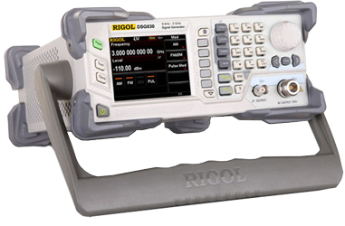

Figure 1.1: function generator

# Chapter 2

**CIRCUIT DESCRIPTION**

## Block Diagram

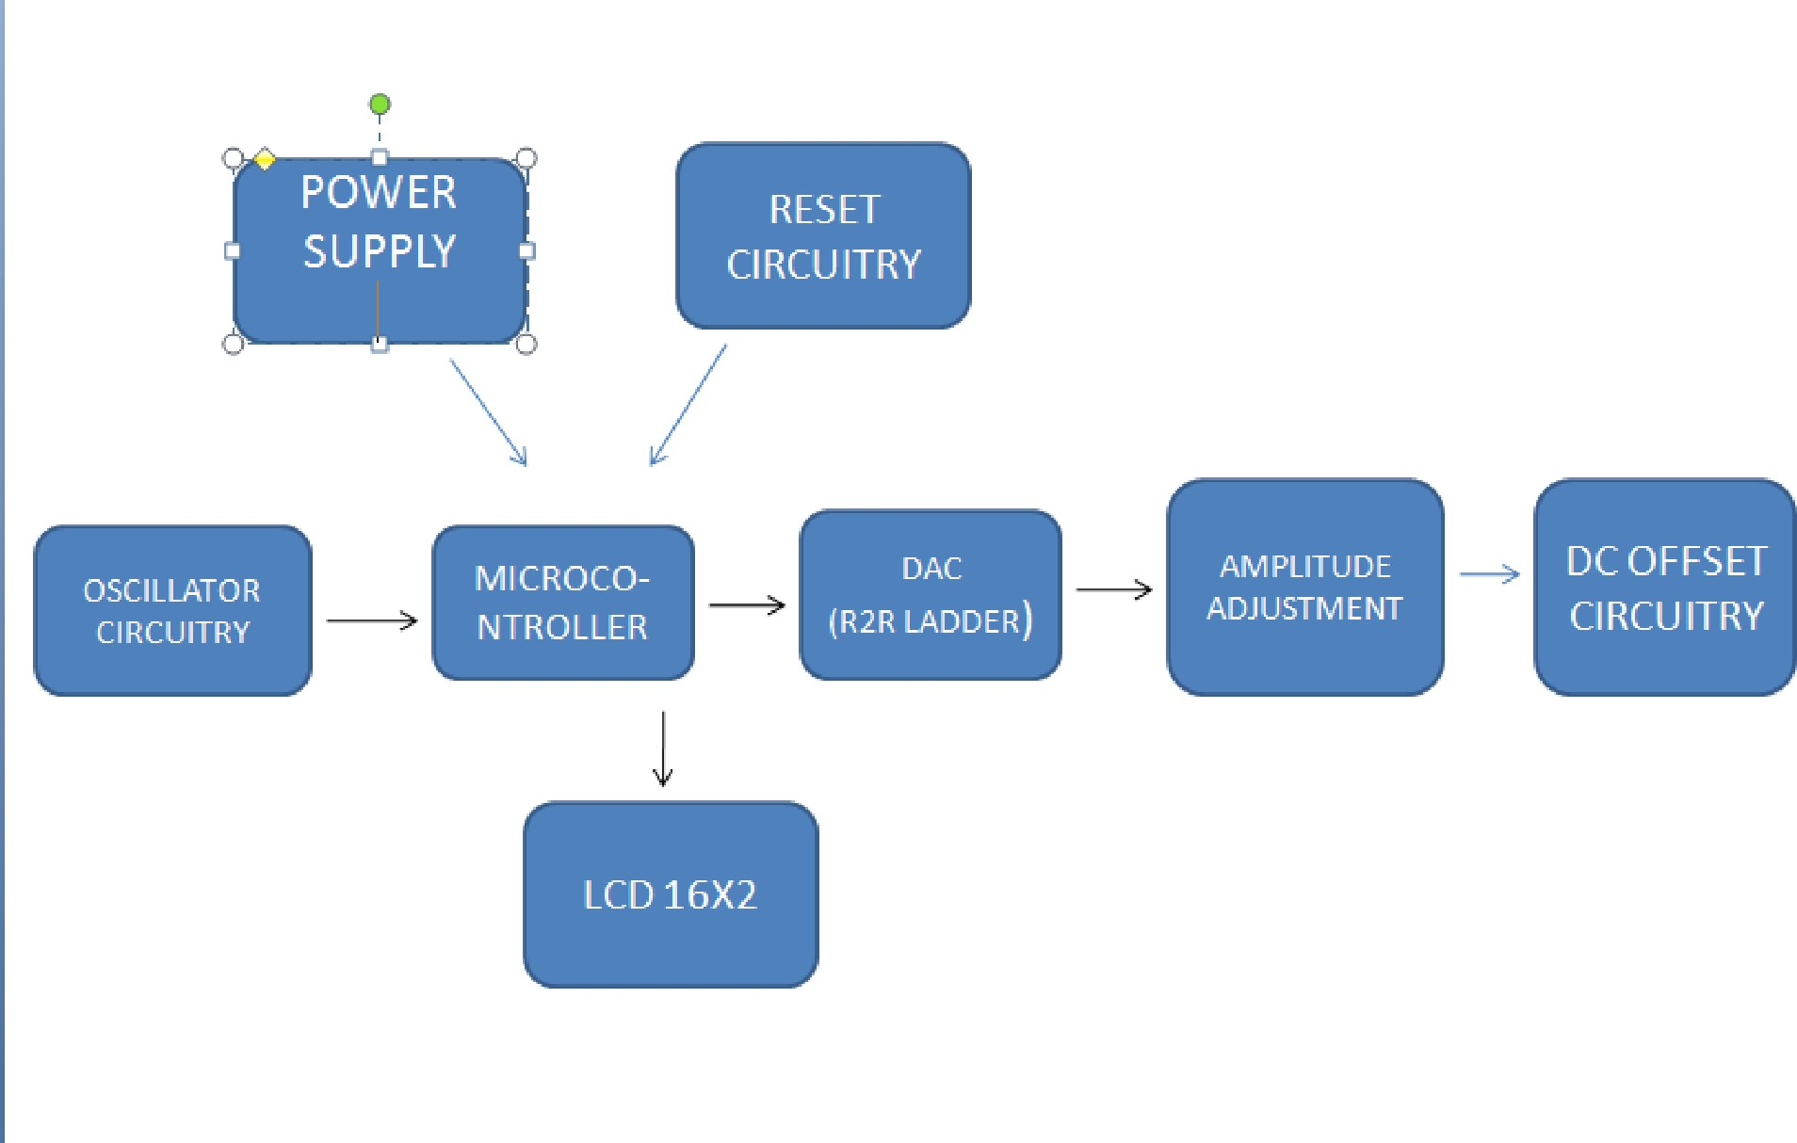

Figure 2.1: Block diagram

3

## Working Principle

It uses Kirchhoff’s current law which states that the sum of currents entering a node must be equal to the sum of the currents leaving a node. In the ladder, at each node, the current is split in half. By switching the currents into each node, the total current flowing is binary weighted.

Using the principle of superposition when you add more current into a resistance the total voltage appearing is the sum of the voltages caused by all the individual currents i.e. as each bit is activated so the voltage increases at the output.

Another clever thing about the R-2R ladder, and the reason that it works is that if you look to the left you always see the same impedance

Thevenin equivalent circuit

Using Thevenin’s theorem you can work out the voltage contribution of each bit. A Thevenin circuit is the equivalent of a network of resistances and voltage sources (and current sources). You can replace the network with a Thevenin equivalent circuit and it will work in exactly the same way as the original network.

To use the Thevenin theorem replace all voltage sources with short circuits and all current sources with open circuits - calculate the resistance looking into the port for the Thevenin resistance Rth. For the Thevenin voltage calculate the no load output voltage.

following are the steps to explain the working of the R2R ladder to convert digital input to analog output: So, the output voltage comes out to be: When each bit is active it contributes a binary weighted voltage to the output Vo.

Vo= D7/ 256 + D6/ 128 + D5/ 64 + D4/ 32 + D3/ 16 + D2/ 8 + D1/ 4 +

D0/ 2

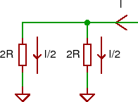

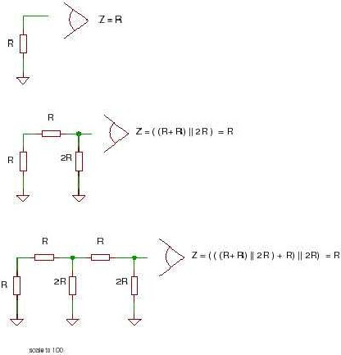

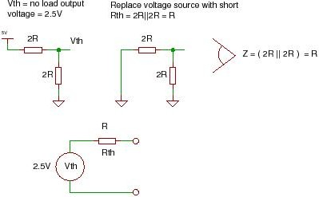

Figure 2.2: For the Thevenin voltage calculate the no load output voltage.

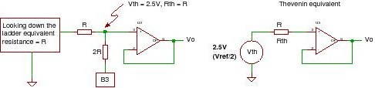

Figure 2.3: Contribution if bit 3 is active (the MSB):

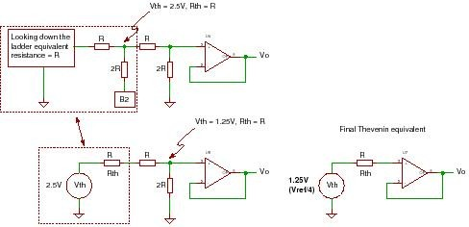

Figure 2.4: Contribution if 2 bits is active (the MSB):

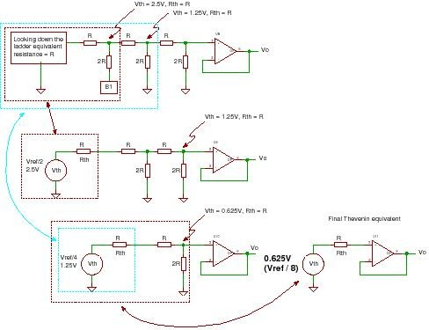

Figure 2.5: Contribution if 1 bit is active (the MSB):

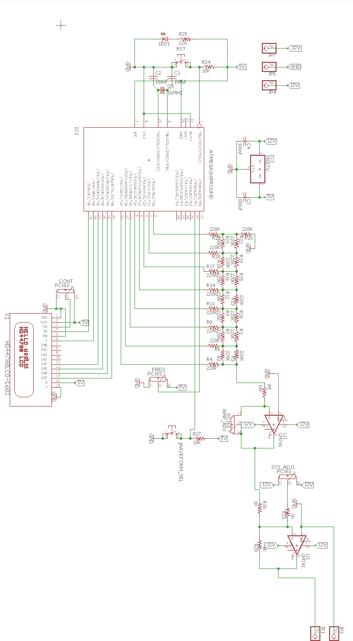

# Chapter 3 Implementation

## Hardware

* + 1. ATMEGA328P

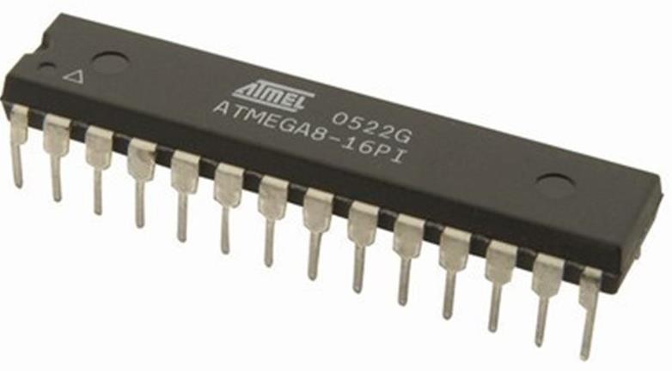

Figure 3.1: Atmega 328P

Features:

* 28 pin PDIP package
* High Performance, Low Power AVR 8-Bit Microcontroller
* Peripheral Features Two 8-bit Timer/Counters with Separate Prescaler Six PWM Channels
* Programmable Serial USART
* Master/Slave SPI Serial Interface
* Byte-oriented 2-wire Serial Interface
* Operating Voltage: 1.8 - 5.5V for ATmega48PA/88PA/168PA/328P
* Temperature Range: -40C to 85C
* Speed Grade: 0 - 20 MHz @ 1.8 - 5.5V
* Low Power Consumption at 1 MHz, 1.8V, 25C for ATmega48PA/88PA/168PA/328P:

9

* Active Mode: 0.2 mA Power-down Mode: 0.1 A

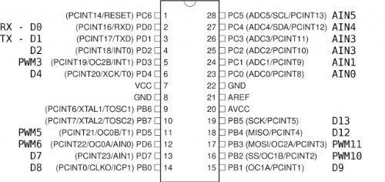

Figure 3.2: PIN DIAGRAM

1.1 Pin Descriptions

* VCC Digital supply voltage.
* 1.1.2 GND Ground.
* Port B (PB7:0) XTAL1/XTAL2/TOSC1/TOSC2

Port B is an 8-bit bi-directional I/O port with internal pull-up resistors (selected for each bit). The Port B output buffers have symmetrical drive characteristics with both high sink and source capability. As inputs, Port B pins that are exter- nally pulled low will source current if the pull-up resistors are activated. The Port B pins are tri-stated when a reset condition becomes active, even if the clock is not running. Depending on the clock selection fuse settings, PB6 can be used as input to the inverting Oscillator amplifier and input to the internal clock operating circuit. Depending on the clock selection fuse settings, PB7 can be used as output from the inverting Oscillator amplifier. If the Internal Calibrated RC Oscillator is used as chip clock source, PB7.6 is used as TOSC2..1 input for the Asynchronous Timer/Counter2 if the AS2 bit in ASSR is set.

* Port C

(PC5:0) Port C is a 7-bit bi-directional I/O port with internal pull-up resistors (selected for each bit). The PC5.0 output buffers have symmetrical drive charac- teristics with both high sink and source capability. As inputs, Port C pins that are externally pulled low will source current if the pull-up resistors are activated. The Port C pins are tri-stated when a reset condition becomes active, even if the clock is not running.

* PC6/RESET

If the RSTDISBL Fuse is programmed, PC6 is used as an I/O pin. Note that the electrical characteristics of PC6 differ from those of the other pins of Port C. If the RSTDISBL Fuse is unprogrammed, PC6 is used as a Reset input. A low level on this pin for longer than the minimum pulse length will generate a Reset, even if the clock is not running. Shorter pulses are not guaranteed to generate a Reset.

* Port D

Port D is an 8-bit bi-directional I/O port with internal pull-up resistors (selected for each bit). The Port D output buffers have symmetrical drive characteristics with both high sink and source capability. As inputs, Port D pins that are exter- nally pulled low will source current if the pull-up resistors are activated. The Port D pins are tri-stated when a reset condition becomes active, even if the clock is not running.

* AVCC

AVCC is the supply voltage pin for the A/D Converter, PC3:0, and ADC7:6. It should be externally connected to VCC, even if the ADC is not used. If the ADC is used, it should be connected to VCC through a low-pass filter. Note that PC6.4 use digital supply voltage, VCC

* AREF

AREF is the analog reference pin for the A/D Converter.

* ADC7:6 (TQFP and QFN/MLF Package Only) In the TQFP and QFN/MLF package, ADC7:6 serve as analog inputs to the A/D converter. These pins are powered from the analog supply and serve as 10-bit ADC channels.
  + 1. RESISTOR:

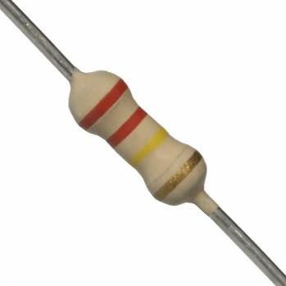

Figure 3.3: Resistor

Features:

* Standard tolerance: +/-5- Excellent long-term stability
* Termination: Standard solder-plated copper lead
  + 1. CRYSTAL OSCILLATOR (16MHz):

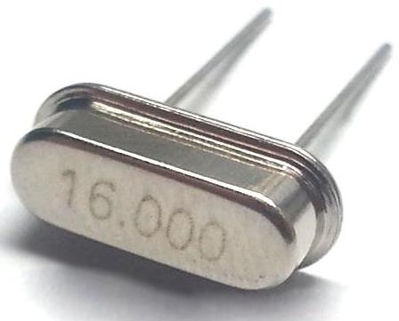

Figure 3.4: Crystal Oscillator

Features and Applications:

* General, industrial, microcontrollers
* Cost Effective
* Wide frequency range
* Metal case
  + 1. CAPACITOR:

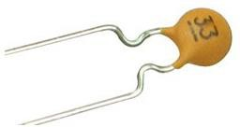

Figure 3.5: Capacitor

Features and application:

* Wide range of sizes and voltages
* Several terminations option
* Robust and reliable design with high stability
* High voltage generation, and AC mains filtering
* High frequency and high voltage / power
* High-reliability, medical, military, and space
  + 1. LED:

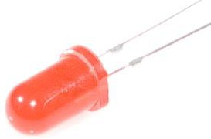

Figure 3.6: LED

Features:

* High luminous power.
* Typical chromaticity coordinates x=0.30, y=0.29
  + 1. Push Button:

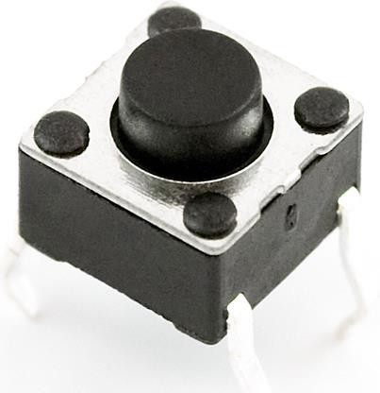

Figure 3.7: Push Button

Features:

* Power Rating: MAX 50mA 24VDC
* Contact Resistance: MAX 100mOhm
* Dielectric Withstanding Voltage: 250VAC for 1 minute
* Contact Bounce: MAX 5mS
  + 1. Potentiometer:

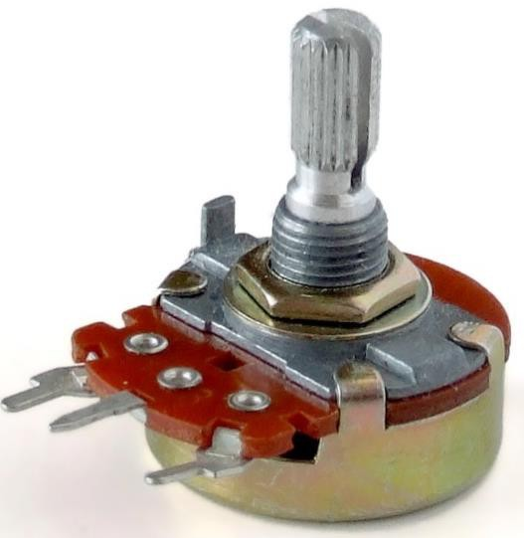

Figure 3.8: Potentiometer

Features:

* Type: Rotary
* Available in different resistance values like 500, 1K, 2K, 5K, 10K, 22K, 47K, 50K, 100K, 220K, 470K, 500K, 1 M.
* Power Rating: 0.3W
* Maximum Input Voltage: 200Vdc
* Rotational Life: 2000K cycles
  + 1. LCD:

Features:

* 5x8 dots with cursor
* 16 characters *2line display
* 4bit or 8bit MPU interfaces
* Built in controller
* Backlight

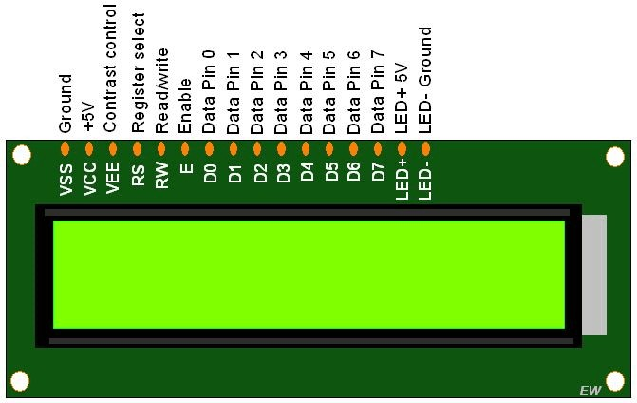

Figure 3.9: LCD

## Software:

EAGLE Software: It is a scriptable electronic design automation (EDA) appli- cation with schematic capture, printed circuit board (PCB) layout, auto-router

and computer aided manufacturing (CAM) features. EAGLE stands for Easily Applicable Graphical Layout Editor (German: Einfach Anzuwendender Grascher Layout-Editor) and is developed by CadSoft Computer GmbH. The company was acquired by Autodesk Inc. in 2016. Features: EAGLE provides a multi-window graphical user interface and menu system for editing, project management and to customize the interface and design parameters. The system can be controlled via mouse, keyboard hotkeys or by entering specific commands at an embedded com- mand line. Multiple repeating commands can be combined into script les (with le extension .SCR). It is also possible to explore design les utilizing an EAGLE- specific object-oriented programming language (with extension. ULP) History: The German CadSoft Computer GmbH was founded by Rudolf Hofer and KlausPeter Schmidinger in 1988 to develop EAGLE, a 16-bit PCB design application for DOS. Originally, the software consisted of a layout editor with part libraries only. A schematic editor and an auto-router module became available as optional components later on. In 1992, version 2.6 changed the dentition of layers, but designs created under older versions (up to 2.05) could be converted into the new format using the provided UPDATE26.EXE utility. EAGLE 3.0 was changed to be a 32-bit extended DOS application in 1994. On 27 June 2016, Autodesk announced the acquisition of Cad Soft Computer GmbH from Premier Farnell, with Premier Far- nell continuing to distribute Cad soft products for Autodesk. Autodesk changed the license to a subscription-only model starting with version 8.0.0 in 2017. Only 64-bit versions remain available any more. The le format used by EAGLE 8.0.0 and higher is not backward compatible with earlier EAGLE versions.

Steps to Use Eagle:

1: Starting New Project and Adding Components First open eagle.scad then you need to hover over FILE then NEW then click on schematic. After that you should have a new window pop up. This is where you are going to draw your schematic. To add a component, you need to click the add button. Then add your component. Click OK and you should have the schematic sign of your component, just click and it will be added. That I show you add a part. Keep doing that Intel you have all the parts you need. To turn a component all you have to do is right click.

2: Connecting Components To connect your components you have to click the wire button. Then click on one part you want to connect then click the other. If you right click then the angle that the line turns at and direction will change.

3: Converting Schematics to Boards To convert your schematic to a board all you have to do is press the board button. Ones you clicked that a window should pop up and you should see your components outside of the square.to move your components click the move button. The yellow lines that you see connecting your

components mean that they are unrouted. There are 2 ways to rout your com- ponent.one way is by hand and the other way is using the auto route button. To rout by hand, you click the rout button then click the two ends of the components. When the line that you make is red then it’s on the top of the board if the line is blue than it is on the bottom.to use auto route just click auto.

4: Other Things You can also add text in your board all you have to do is click the button that seas text, type what you want it to say then click ok. Your text might come up in red or blue this Is not good but it is ease to x. All you have to do Is click select layer button then add ether Tsilk or Bsilk. Tsilk means that your text will be on the silk layer on the top of the board. Bsilk means that your text will be on the bottom of the board. Then click where you want your text to be just make sure that it is not over any holes, or pads.

5: Finished

## Arduino Software:

Arduino is an open-source platform used for building electronics projects. Ar- duino consists of both a physical programmable circuit board (often referred to as a microcontroller) and a piece of software, or IDE (Integrated Development Envi- ronment) that runs on your computer, used to write and upload computer code to the physical board.

The Arduino platform has become quite popular with people just starting out with electronics, and for good reason. Unlike most previous programmable circuit boards, the Arduino does not need a separate piece of hardware (called a program- mer) in order to load new code onto the board you can simply use a USB cable. Additionally, the Arduino IDE uses a simplified version of C++, making it easier to learn to program. Finally, Arduino provides a standard form factor that breaks out the functions of the micro-controller into a more accessible package

# Chapter 4

**PCB MAKING**

## 4.1 Steps for PCB Making Process:

STEP 1: Take printout of the negative photo resist PCB layout on butter paper.

STEP 2: Cut the copper clad according to the size of your PCB layout circuit leaving enough spaces at the boundaries to hold them.

STEP 3: Scrub the cut copper clad thoroughly in order to clear the dust par- ticles on the surface.

STEP 4: Dip this cleared copper clad in the photo resist solution and carefully drip o the extra solution.

STEP 5: Keep this wet copper clad in the oven at 50oC for about two to three minutes until it is dried up.

STEP 6: Next keep the butter paper print out on top of which the copper clad is kept in the device through which we are going to pass UV light in order to print the circuit layout on the copper clad for about 5 minutes.

STEP 7: After that dip the clad into developer solution, after which the print will be partially visible.

STEP 8: Final step is to make this partially visible layout properly visible by dipping the clad into FeCl3 solution and keep checking the copper clad after 5 to 10 minutes else there are chances of it getting burnt. Wash it with water then let it dry.

18

Step 9: After all these processes we will get a properly printed PCB lay- out.

Step 10: Next drill the holes for the terminals of components.

Step 11: Then t the components as per circuit and solder them.

Step 12: Test for the output and the project is ready.

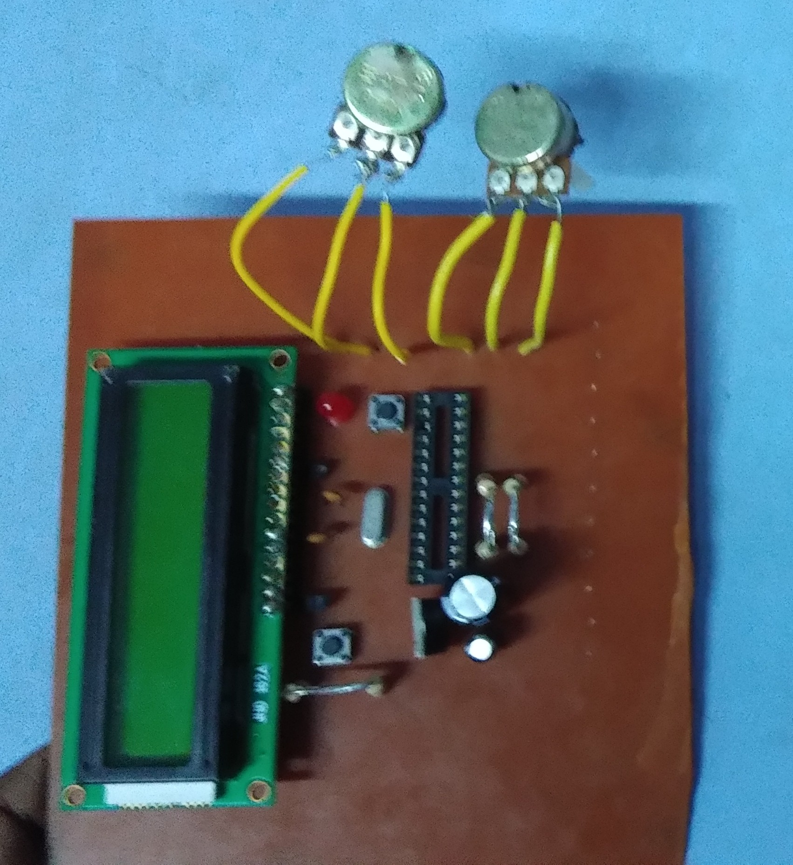

Figure 4.1: PCB

# Chapter 5 RESULT:

Result and discussion here.

## Advantages:

* + - It can generate a wide range of frequencies.
    - Frequency stability of 0.1 percent per hour for analog generators

Maximum sinewave distortion of about 1generators. [5] Arbitrary waveform generators may have distortion less than -55 dB below 50 kHz and less than

*•*

-40 dB above 50 kHz.

Some function generators can be phase locked to an external signal source, which may be a frequency reference or another function generator.

*•*

Amplitude modulation (AM), frequency modulation (FM), or phase modu- lation (PM) may be supported.

*•*

* + - Output amplitude up to 10 V peak-to-peak.
    - Amplitude can be modified,

Usually by a calibrated attenuator with decade steps and continuous adjust- ment within each decade.

*•*

* + - Some generators provide a DC offset voltage, e.g. adjustable

It is used for synchronizing another device (such as an oscilloscope) to the possibly variable main output signal.

*•*

20

# Chapter 6

**CONCLUSION AND FUTURE SCOPE**

## Conclusion

Finally, this frequency generator offers a constant signal quality until f=1kHz. For most of the purposes the signal quality is good enough until 10kHz. Depended on the signal requirements even for some purposes signal qualities above 10kHz are sufficient. For our project we made a simple function generator circuit which produce square, triangular and sine wave. This circuit will be run and worked properly. For all the waveform we recognize, but minor distortion in sine wave, we can’t recognize properly in simple CRO but in digital CRO it will be seen clearly.

## Future scope

The emergence of digital modulation technology and wireless technologies like wire- less interoperability for microwave access (WiMAX), wideband code division mul- tiple access (WCDMA), global system for mobile communication (GSM) and 3G wireless are driving the growth of AWGs, RF and microwave function generators. On the technological front, these generators are moving towards a higher band- width and dynamic range.

High speed DACs: The technical trends driving the industry in the arbitrary segment are the high-speed digital-to-analogue converters (DACs) providing up to 16-bit resolution at sample rates in excess of 1 GSa/s.

21

Modular designs to serve specific purposes: The generator can be equipped with a maximum of two internal baseband modules and four fading simulator modules. It is also possible to install a second 3 GHz or 6 GHz RF path. The SMW200A offers exceptional compactness and uses the latest FPGA technology so that up to four of the powerful fading modules can be installed. These modules can simulta- neously emulate as many as 16 fading channels. The maximum fading bandwidth is 160 Mhz.

One device for multiple purposes: For various multi-function receivers, such as mobile phones and car navigation systems, it is necessary to evaluate interference from other built-in systems. The MG3710A features wideband vector modulation and offers built-in baseband waveform generation with deep memory to ensure maximum versatility. It supports key mobile communications and wireless LAN standards, and it also has the exceptional performance required for emerging and proprietary wireless communications technologies, informs Madhukar Tripathi, re- gional manager, Anritsu Pte Ltd, India.

High performance and signal fidelity: Along with a modular structure, manu- facturers are currently focusing on expanding the bandwidth and frequency range of function generators.

# References

* + 1. h[ttps://www.arduino.cc/en/Tutorial/ArduinoT](http://www.arduino.cc/en/Tutorial/ArduinoToBreadboard)oBreadb[oard](http://www.arduino.cc/en/Tutorial/ArduinoToBreadboard)
    2. h[ttps://www.electronics-notes.com/articles/test-met](http://www.electronics-notes.com/articles/test-methods/signal-)ho[ds/signal-](http://www.electronics-notes.com/articles/test-methods/signal-) generators/function-generator.php
    3. <http://www.best-microcontroller-projects.com/R-2R-ladder.html>

23